Interesting Query
- Regular Customer
This is the customer which has maximum number of Bokings or maximum amount of spending
Match (c:Customer)-[*]->(invoice:Invoice)
return sum(invoice.amount) as Total_spend,c as Customer
order by Total_spend DESC
Limit 1

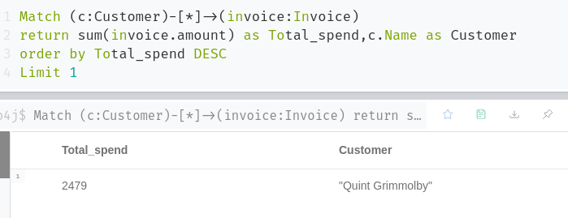

Then we can search the user by their id:
Match (c:Customer{ Customer_id:10})
return c

Using the above method we can find more users who mostly watch movies and can notify when new movies released.
Also we can find out his prefered Genre and language for the particular user.
For Genre->
MATCH (c:Customer{ Customer_id:10})--(movie:Movie)
return movie.Genre,count(movie.Genre)

For Language->
MATCH (c:Customer{ Customer_id:10})--(movie:Movie)
return movie.Language,count(movie.Language )

You can suggest the movies with the similar Language and Genre using
For Language
MATCH (movie: Movie{ Language: "Danish"})
return movie

For Genre
MATCH (movie: Movie{ Genre: "Comedy”} })
return movie

- Interesting Movies
Some movie do well in box office but some time people does not recommend other to watch. So I seperate the movies success in terms of collection and in terms of review ratings from viewers.

Using Customers Rating
With high rating --→>>
Match (c:Customer)-[r]->(movie:Movie)
return avg(r.rating) as Average_rating,movie
order by Average_rating DESC
Limit 1
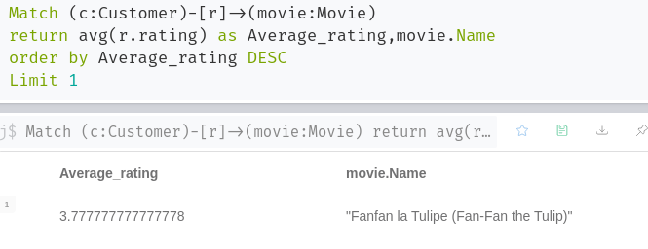

With low rating
Match (c:Customer)-[r]->(movie:Movie)
return avg(r.rating) as Average_rating,movie
order by Average_rating
Limit 1

Using Customer data/ Booking Collection

With high income
match (invoice:Invoice)<-[]-()-[]->(c:Shows)-[]->(movie:Movie)
return avg(invoice.amount) as Collection,movie
order by Collection DESC
Limit 1
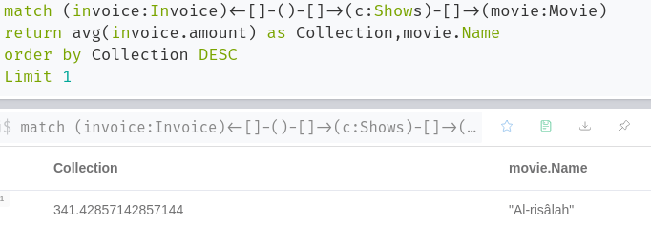
With Low income
match (invoice:Invoice)<-[]-()-[]->(c:Shows)-[]->(movie:Movie)
return avg(invoice.amount) as Collection,movie
order by Collection
Limit 1

Then we can search the corresponding movies director movie and recommend then
Match (movie:Movie { Name:"xxxxx"})
return movie

- Movies Collection of movies
Given movie id it search and provide the total collection
match (invoice:Invoice)<-[]-()-[]->(c:Shows)-[]->(movie:Movie{Movie_id:5})
return avg(invoice.amount) as Collection,movie

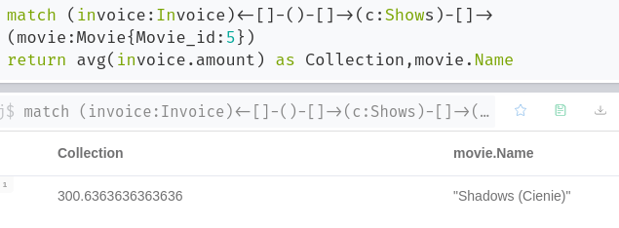
- Blockbuster Director
Box office based / High income

match (invoice:Invoice)<-[]-()-[]->(c:Shows)-[]->(movie:Movie)
return avg(invoice.amount) as Collection,movie.Director
order by Collection DESC
Limit 1
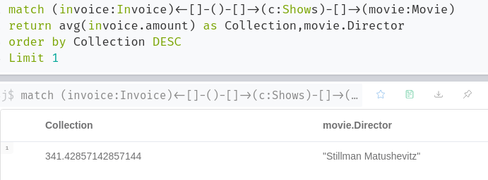
We cannot compare by low income because for new director it will be unfair.
Fan based: by rating
Match (c:Customer)-[r]->(movie:Movie)
return avg(r.rating) as Average_rating,movie.Director
order by Average_rating DESC
Limit 1
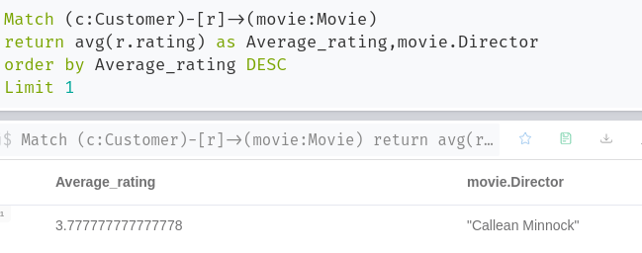
similarly we can get worst with fan rating
Match (c:Customer)-[r]->(movie:Movie)
return avg(r.rating) as Average_rating,movie.Director
order by Average_rating
Limit 1

And then we can suggest the movies of the director.
Match (movie:Movie { Director: XXX})

- Most released Genre/Language based on year
For Genre for year 2003
Match (movie:Movie {Year_of_make:"2003"})
return movie.Genre,count(movie.Genre) as Total_Release_on_2003
order by Total_Release_on_2003 DESC
limit 1
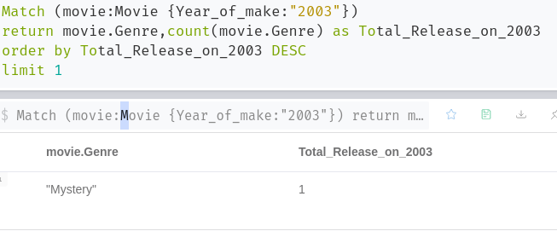

For Language for year 2003
Match (movie:Movie {Year_of_make:"2003"})
return movie.Language,count(movie.Language) as Total_Release_on_2003
order by Total_Release_on_2003 DESC
limit 1

We can recommend the highest ratings movie from the above known categroy
Since max rating is 5 we can recommend best rating movie to all user irrespective of user’s prefered Genre and Language which we have done in Queries 2.

- Theatres rates
Calculating average rating of one seats per cinema
Expensive
Match (theatre:Theatre)-[]->(seat:Seat)
return avg(seat.price) as Average_rates , theatre
order by Average_rates DESC
limit 1
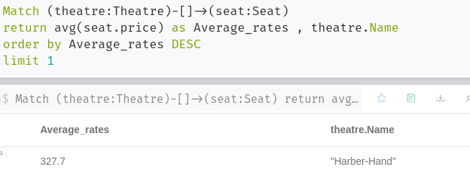

Cheapest
Match (theatre:Theatre)-[]->(seat:Seat)
return avg(seat.price) as Average_rates , theatre
order by Average_rates
limit 1

- Movies on cinema
Using the status available in shows
Match (show:Shows{status:"Available"})-[r]->(movie:Movie)
return movie.Name as Movies
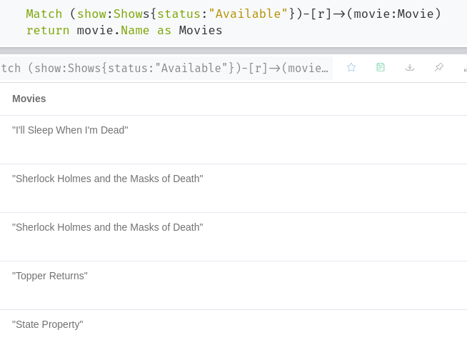
- Viral Movies
This term is used as to check which movie gains highest no of customers concern according to reviews

Match (c:Customer)-[r]->(movie:Movie)
return count(r.review) as Total_review,movie.Name
order by Total_review DESC
LIMIT 1
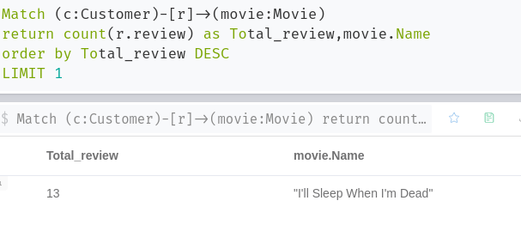
Highly Appriciated Movie
Taking “is a good movie” text as good comment

Match (c:Customer)-[r]->(movie:Movie)
where r.review CONTAINS "is a good movie"
return count(r.review) as Good_review,movie.Name as Movie
order by Good_review DESC
limit 1

Highly Criticised
Taking “could be better” as bad comment
Match (c:Customer)-[r]->(movie:Movie)
where r.review CONTAINS "could be better"
return count(r.review CONTAINS "should be better") as Bad_review,movie.Name as Movie
order by Bad_review DESC
LIMIT 1
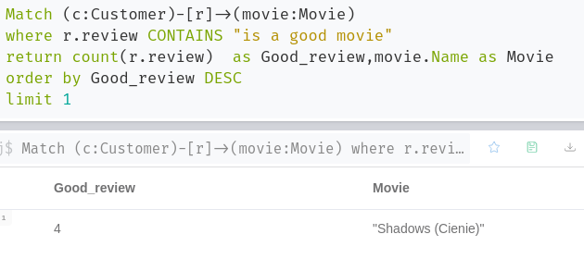

- Customer Range
Tried to work on but it is too difficult using this--------→NOOOOO OUT PUT
Age Group of Users who are enrolled to system to target the customers
Match (c:Customer)
WITH c.Age as age ,
REDUCE(acc='',
r in [ [0,10,'group1'], [10,20,'group2'], [20,30,'group3'], [30,50,'group3'] , [50,80,'group3']] |
acc + CASE WHEN age>=r[0] AND age<r[1] THEN r[2] ELSE '' END
) as group
WHERE size(group)>0
RETURN group, count(age)
- Suspicious Customer
We can Increase the limit number to find the details for customer who cancelled most booking
For most cancellation
match (c:Customer)-[r]->(booking:Booking{ status:"Canceled"})
return count(booking) as cancelation,c as Customer
order by cancelation DESC
Limit 1
Similarly for other status
match (c:Customer)-[r]->(booking:Booking{ status:"Pending"})
return count(booking) as pending,c as Customer
order by pending DESC
Limit 1

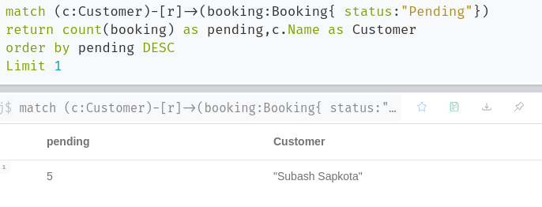
For inspection particular customer

match (c:Customer{Customer_id:10})
return c

